
2017 Varsity Lakes Race 2
& Northern Marathon Series 1
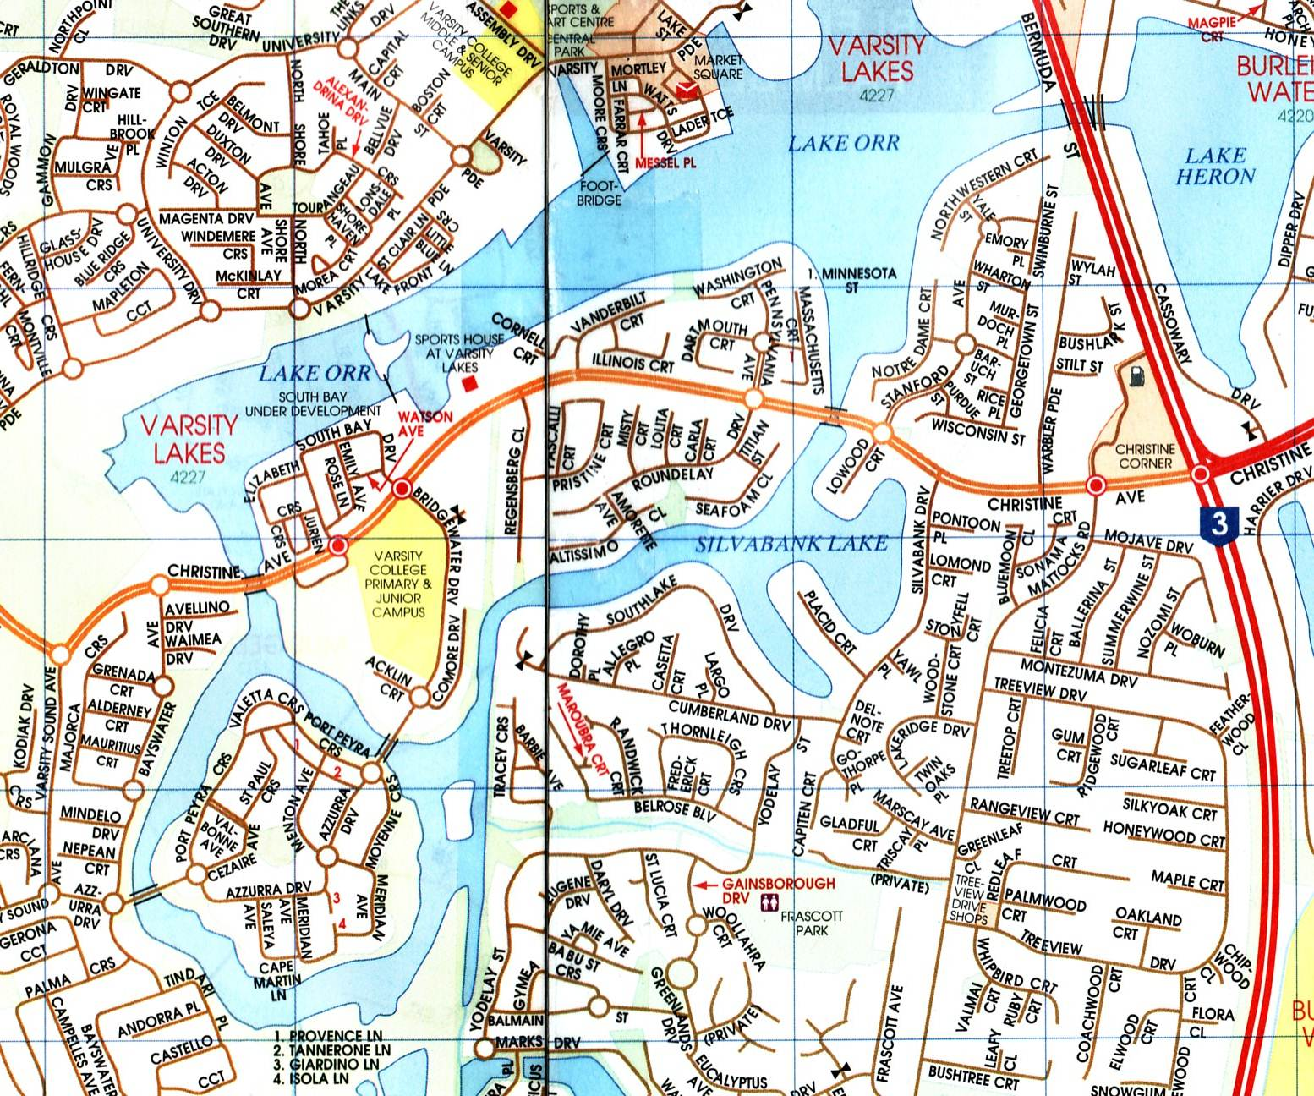

When? Sunday 30th April 2017

Start? 7:15am – 8:15am Registation
8:30am Briefing
9:00am Race will start

Distance? 5.8km, 10.6km or 15.4km for all.
3km for Under 12yrs only.

You will race over a fixed course of 4.8km loops with a 1km start loop,

3km Junior race will be 1km loops, all within the enclosed waters of Varsity Lakes Waterways.
Enter and exit from a sandy beach area.

Where? Sports House at Varsity Lakes
337 Christine Ave, Varsity lakes

Entry fee? $10 – Only Under 12yrs Juniors
$ 15 – Senior & other Junior A.C. Club financial members
$ 25 – Senior Non A.C members (includes trial insurance)
$ 20 – Junior Non A.C members (includes trail insurance)

Boat classes – K’s, TK’s, C’s, Ski’s, Rec’s, TC’s, OC1’s and SUP’s.

Entries – Preferably online Varsity/NMS Race Entry form (before Sat 29th 6:00pm)
Entries can also be taken on Race Day and via the email below.
All entry fees paid on the day.
A Race start list will also be available for viewing to all entries processed before Race day.

- BBQ and cold drinks available at the venue

A.C. Marathon Rules apply; all boats must have fixed buoyancy. Junior U/14 paddlers and non-swimmers must wear approved P.F.D.’s
Web site: www.varsitylakespaddlers.canoe.org.au email: paddling101@gmail.com
Varsity Race 2/NMS
Race consists of 4.8 km loops
With 1km start loop
Evacuation points

Direction of turns

Direction of race

Turning Buoys

Start Line

Finish line, Event control, First Aid

