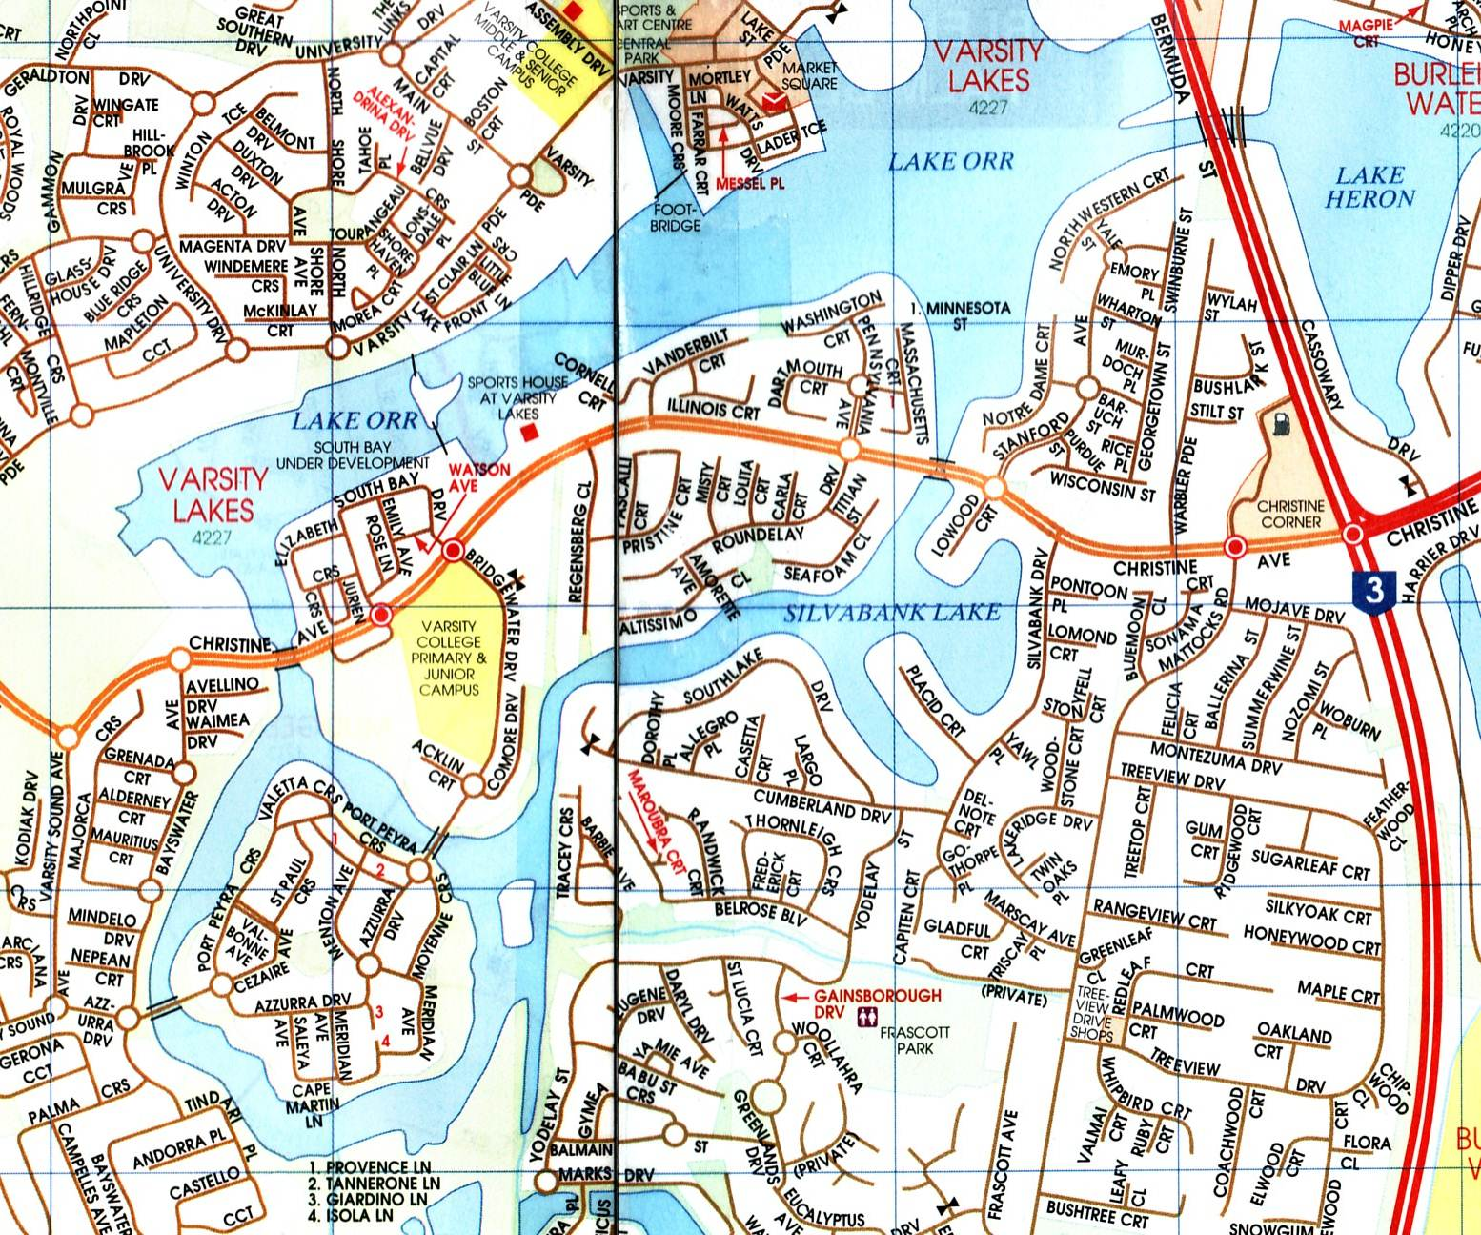


Varsity Lakes
Race 3

When? 1st November 2015
Start? 7:00am – Sign on
8:30am – Briefing
9:00am – Race start

Distance? 5km {2x (1x2.5km)} or 10km {2x (2x2.5km)}
This race is over a fixed course of 2.5km loops, all within the enclosed waters of the Varsity Lakes Waterways. Start and finish from a sandy beach area.
This race is a little different – this one’s for fun, the distance will be race in half’s (2 mini races). You will race twice at different times, get a time for each race & add them together for a total time. The idea is one group of craft (eg. Tk’s & Rec’s) will race their 1st mini race, hop off the water, then the other craft (eg. K’s & Ski’s) will race their 1st mini race, when finished, we’ll do it all again.

This race is also the Presentation of the 2015 Paddlers Cup

Where? Sports House at Varsity Lakes
337 Christine Ave, Varsity lakes

Entry fee? $ 12 – Senior & Junior A.C. Club financial members
$ 18 – Senior Non A.C members (includes trial insurance)
$ 16 – Junior Non A.C members (includes trail insurance)

Race entries will be taken on the Day!!
Boat classes – K’s, TK’s, Surf Ski’s, Ocean Ski’s, Rec’s, C1’s.

A.C. Marathon Rules apply; all boats must have fixed buoyancy. Junior U/14 paddlers and non-swimmers must wear approved P.F.D.’s
Ian Frost 0414785080
Web site: www.varsitylakespaddlers.canoe.org.au email: paddling101@gmail.com

