Varsity Lakes Series
Race No. 2
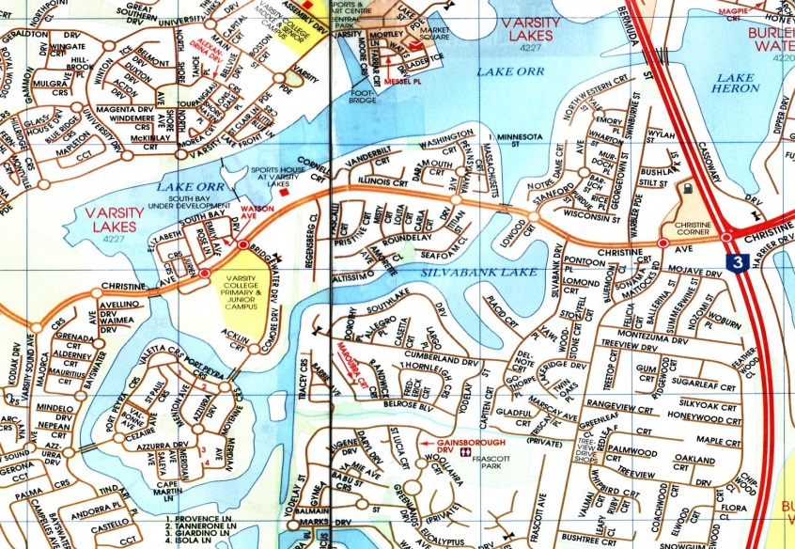

When? Sunday 22 March 2015

Start? 7:00-8:15am – Sign on 8:30am – Briefing
9:00am – Race start

Distance? 5km, 10km or 15km. Race over a fixed course of 5km loops, all within the enclosed waters of the Varsity Lakes Waterways.
This race will be a different course layout to Race No.1; the loops will be around Azzurra Island & back out again into Lake Orr.

Enter and exit from a sandy beach area.
- This is also the 1st race of 2015 Northern Marathon Series
- This is also part of Chris Hurley’s Paddlers Cup.
Where? Sports House at Varsity Lakes
337 Christine Ave, Varsity lakes

Entry fee? $ 12 - Competition members
$ 15 - Recreation members
$ 17 – Senior Non A.C members (includes trial insurance)
$ 15 – Junior Non A.C members (includes trail insurance)
Boat classes – K’s, TK’s, C’s, Ski’s, Rec’s and OC1’s.

- BBQ and cold drinks available at the venue
A.C. Marathon Rules apply; all boats must have fixed buoyancy.
Junior U/14 paddlers and non-swimmers must wear approved P.F.D.’s
Web site: www.varsitylakespaddlers.canoe.org.au email: paddling101@gmail.
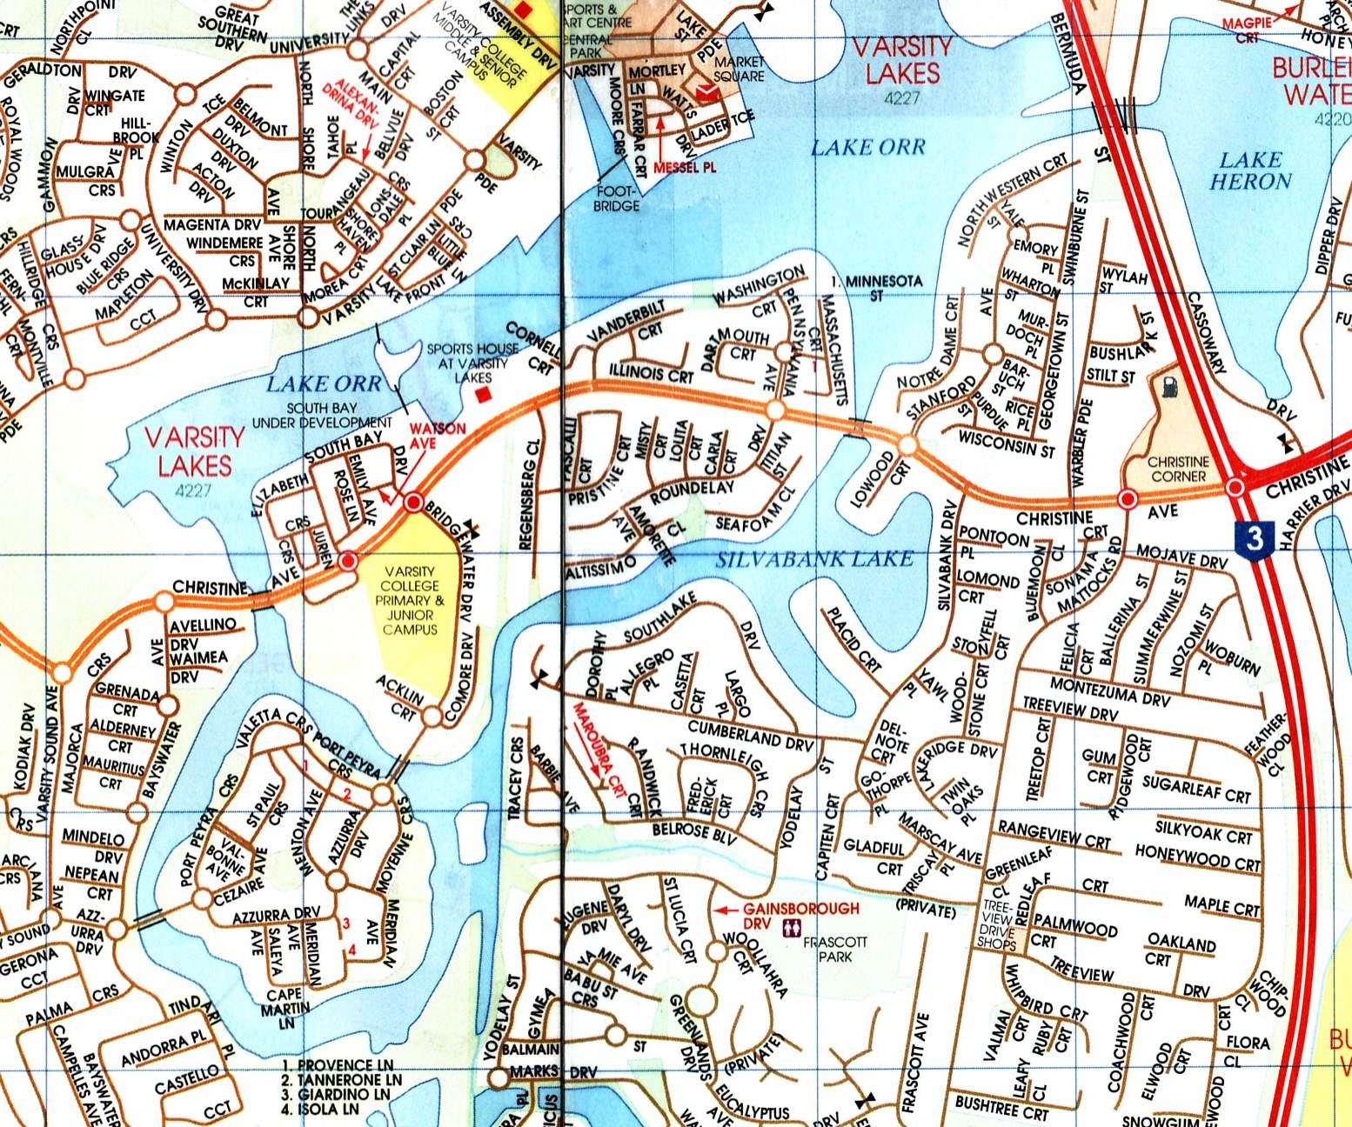
Evacuation points

Direction of turns

Direction of race

Turning Bouys

Start Line

Finish Line
Event control/ First Aid
Varsity Lakes Race No. 2
Race consists of 5km loops

