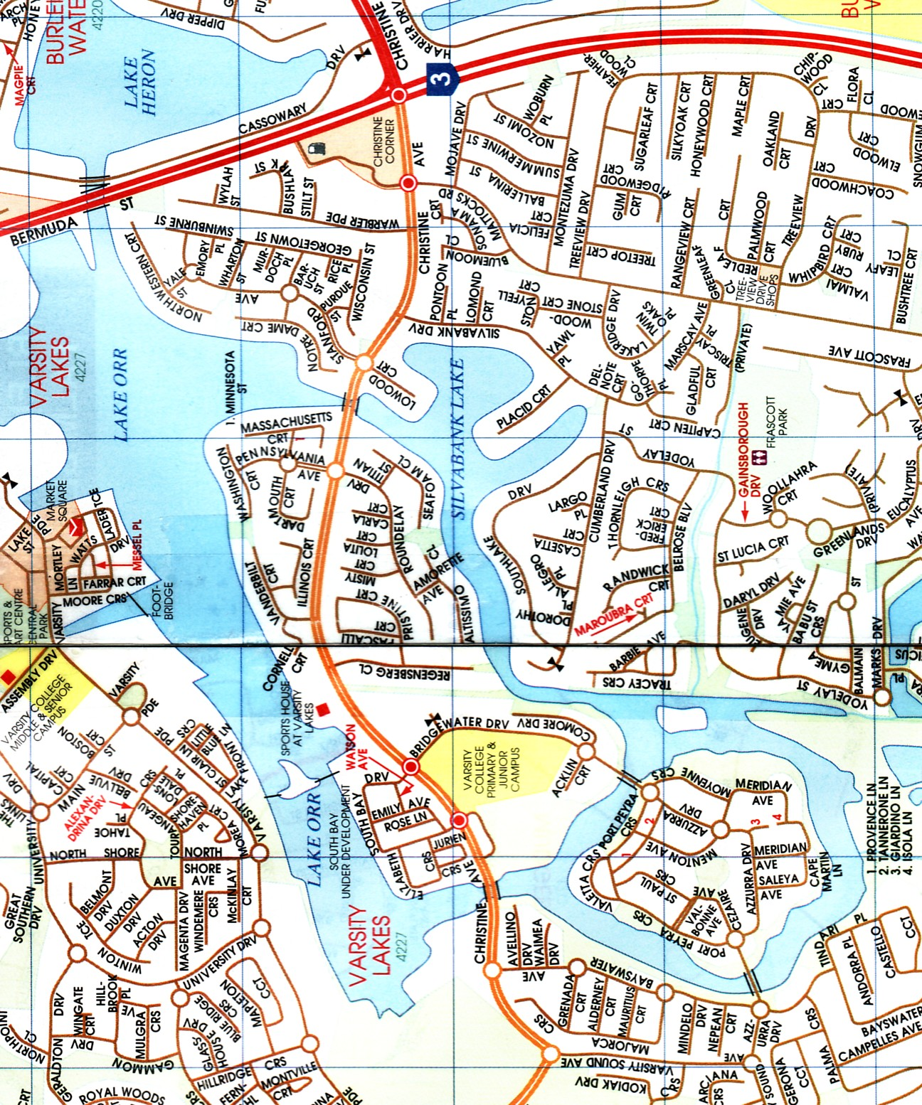

#Start/Finish & evacuation points #Race direction #Buoys

Varsity Lakes Race No. 1