
2015 Varsity Lakes Series
Race No. 1
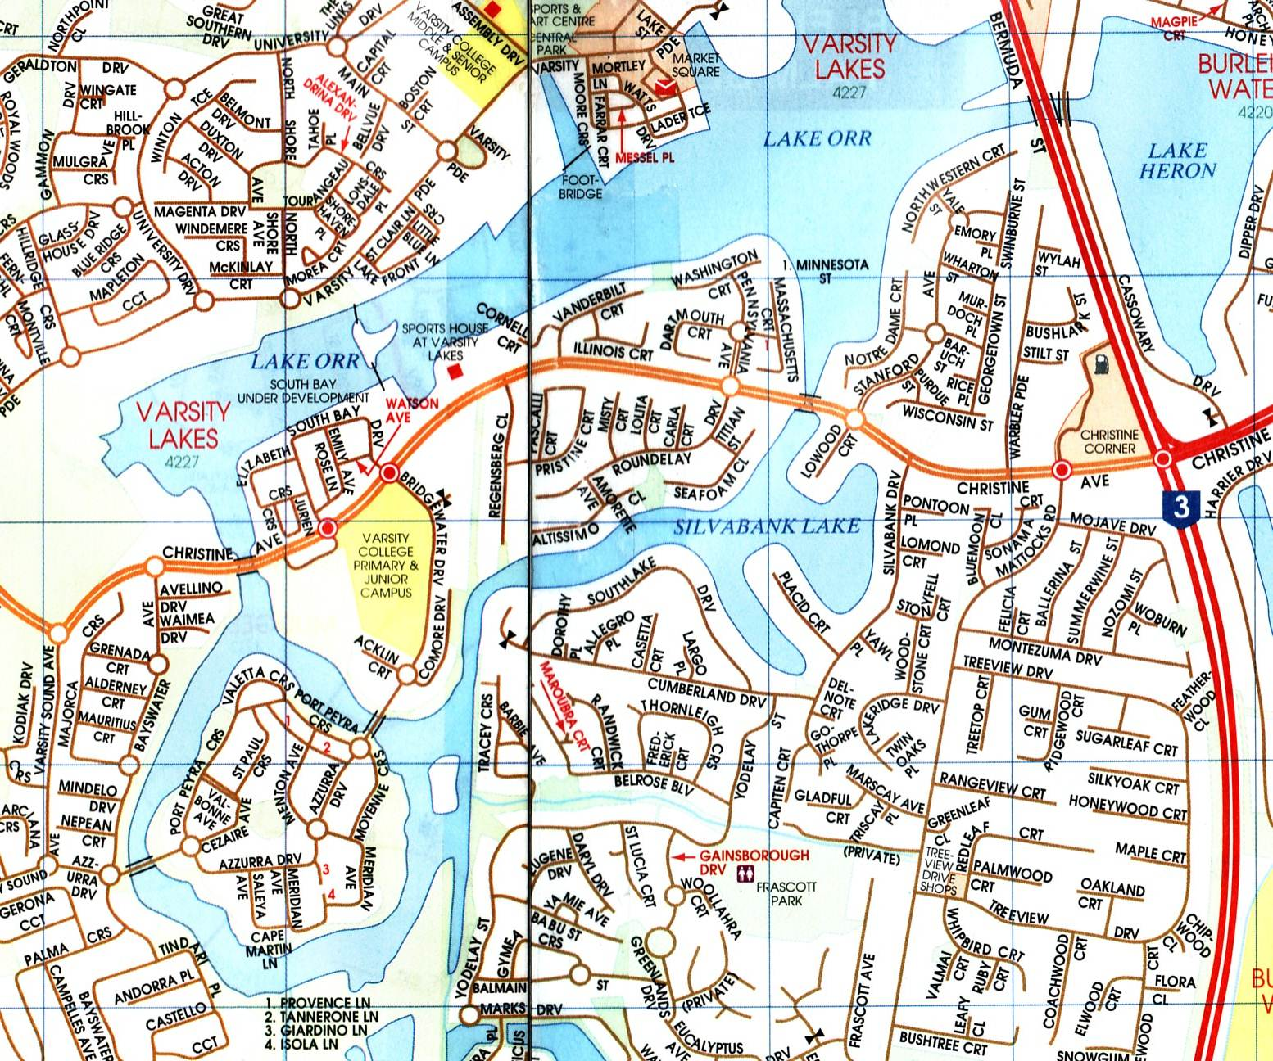

When? Sunday 8th Feb 2015

Start? 7:30-8:15am – Sign on
8:30am – Briefing
9:00am – Race start

Distance? 5km, 10km or 15km. Race over a fixed course of 5km loops, all within the enclosed waters of the Varsity Lakes Waterways.
Enter and exit from a sandy beach area.


- This is also a part of Chris Hurley’s 2015 Paddlers Cup.

Where? Sports House at Varsity Lakes
337 Christine Ave, Varsity lakes

Entry fee? $ 12 - Competition members
$ 15 - Recreation members
$ 17 – Senior Non A.C members (includes trial insurance)
$ 15 – Junior Non A.C members (includes trail insurance)
Boat classes – K’s, TK’s, C’s, Ski’s, Rec’s and OC1’s.

- This is our 1st race of the 2015 Series. Our other races will be in March & Nov. Hope to see you all again!!
- BBQ and cold drinks available at the venue

A.C. Marathon Rules apply; all boats must have fixed buoyancy. Junior U/14 paddlers and non-swimmers must wear approved P.F.D.’s

Web site: www.varsitylakespaddlers.canoe.org.au email: paddling101@gmail.com

