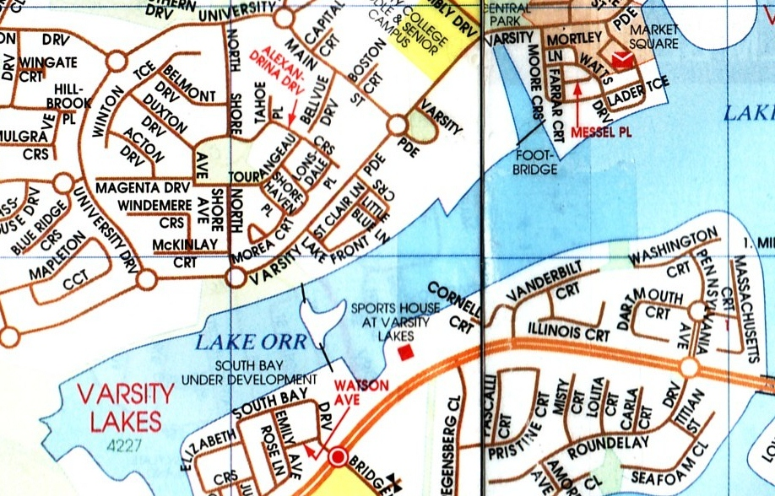

Varsity Lakes Race No.4

**Race consist of 2.5km loops**

 Direction of turns

 Direction of race

Turning Bouys

 Start/Finish Line

Event control/First Aid

& Evacuation point